Highest and Best Use
Student’s Name
Institution
Date

Highest and Best Use
Highest and Best Use denotes the rationally probable and legal use of property regarded to be physically possible, nearly supported, and financially achievable resulting in the highest value (Ribera et al., 2020). According to the Appraisal Institute, Highest and Best Use is defined as “the reasonably probable and legal use of vacant land or an improved property that is physically possible, appropriately supported, financially feasible that attains the highest value.”
Test of Highest and Best Use must inculcate various terminologies. Foremost, legally permissible that denotes the uses considered legally permitted. Uses that are not legally permitted are excluded from zoning, land use planning as well as uses forbidden by government regulations. Also, physically permissible has to be included in the definition. Physically permissible highlights that any potential use ought to be physically possible. The consideration encapsulates consideration of the size, shape topography as well as other features of the site. Also, the property must exhibit financial feasibility. A property has to be financially feasible to produce sufficient revenue to rationalize the costs of construction along with the profit for the developer (Fanning, Wright, & Muenks, 2019). However, the question of financial feasibility is irrelevant in the case of an improved property, with obvious remaining economic life.
Finally, the property must have maximally productive use. The property located within a site has to generate the highest net return – profit – to the developer. Typically, a property must have the potential of generating profits for the developer. Some of the hypothetical development scenarios followed to exemplify the test of maximally productive use include whether a property can be developed with residential, commercial, or industrial development that can only exhibit one of the aforesaid uses as its highest and best use.
Vacant Plots for Sale in Florida
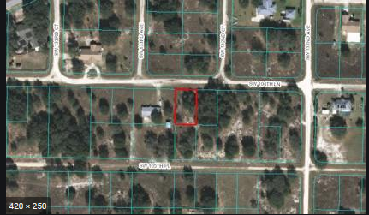

References
Fanning, S. F., Wright, L. T., & Muenks, R. J. (2019). Highest And Best Use And The Property Rights Â€“Does It Make A Difference?. The Valuation Journal, 14(2), 40-82.
Ribera, F., Nesticò, A., Cucco, P., & Maselli, G. (2020). A multicriteria approach to identify the Highest and Best Use for historical buildings. Journal of cultural heritage, 41, 166-177.

